

Widgets

INSTALLATION GUIDE
for Cart Dropdown Accelerator Extension for Magento 1

Step 1 :
Go to your projects root folder & then upload files and folder to the root.

If you have any custom theme then upload theme files to the current theme (app/design/frontend/<Your package>/<Your Theme>).

Step 2 :
Then login to magento admin panel: SYSTEM -> Configuration -> OPENPAY WIDGET -> Widget Setup

1. Enable the module :

Expand 'Openpay Widgets Configuration' & set 'Yes' value against 'Enable Widgets' field.

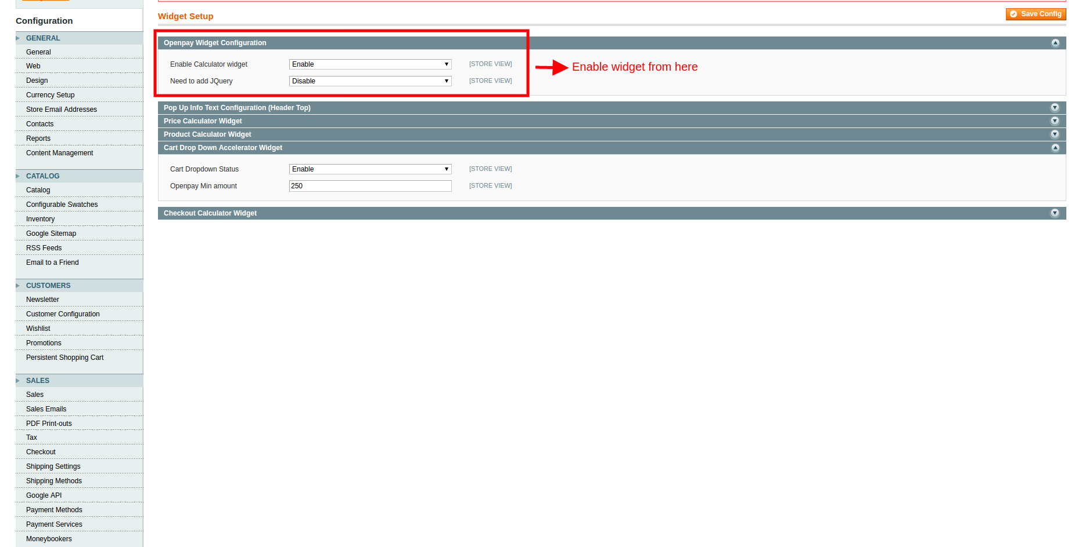

Click on 'Save Config'.

2. Set up 'Cart drop down acceleratorr' widget :

Expand 'Cart drop down accelerator' & fill out the fields as required.

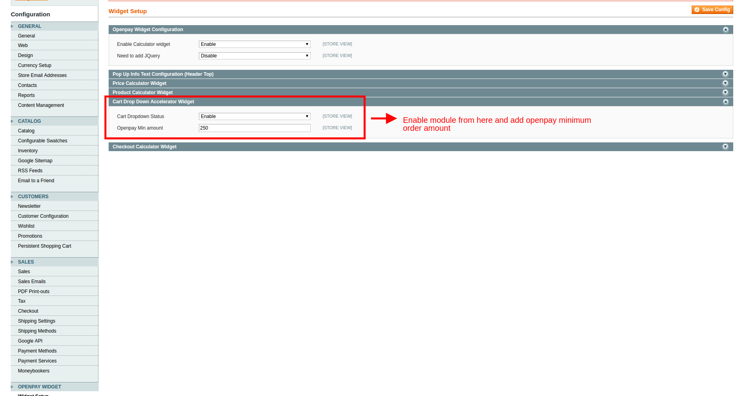

Openpay Min amount : Add openpay pay minimum purchase amount here.
Click on 'Save Config'.

Frontend View :

'Price calculator' widget :

If module is enabled form admin , it will comes in minicart section of site.

